**Q1. Write a script to open the Firefox browser and open** [**https://www.google.com/**](https://www.google.com/) **URL.**

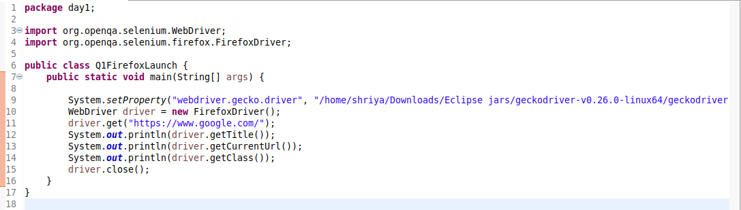

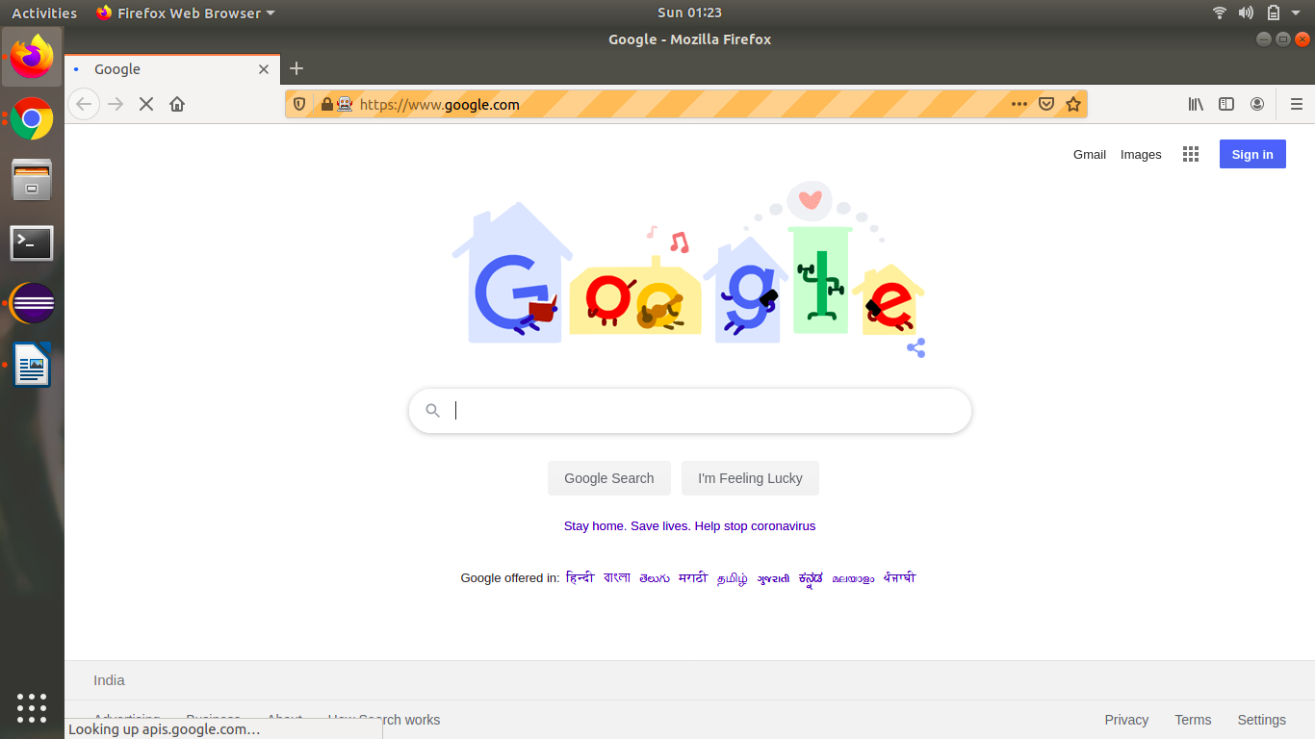

**Q2. Write a script launch the Google Chrome browser and open** [**https://www.google.com/**](https://www.google.com/) **URL.**

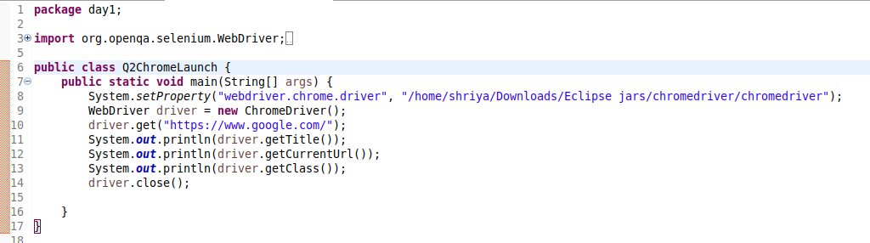

**Q3: Write a script to search the “To The New” string in google.**

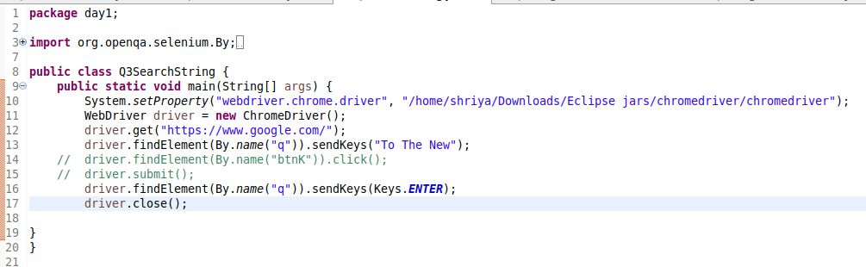

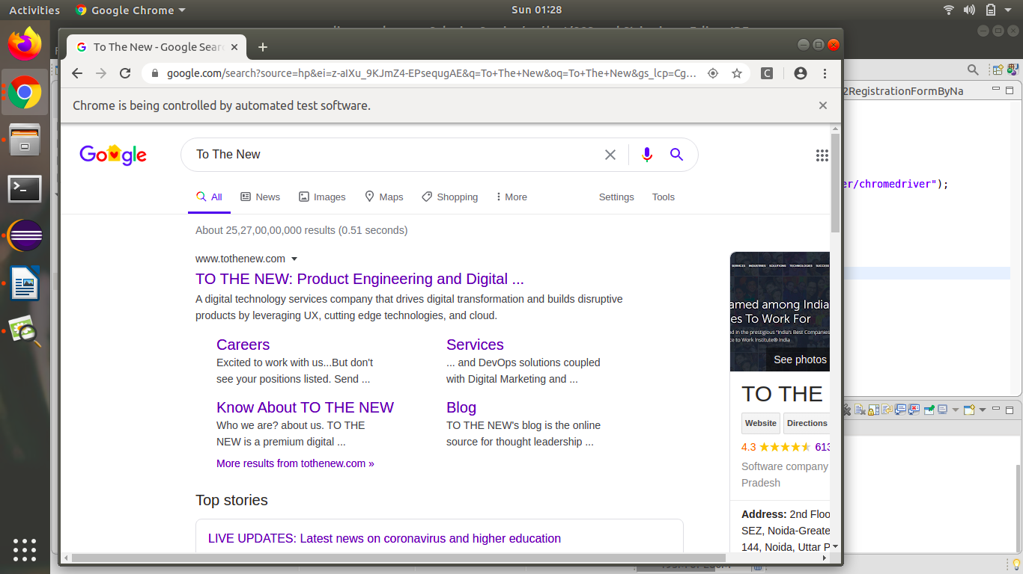

**Q4: Write a script to open** [**http://www.tothenew.com/**](http://www.tothenew.com/) **and then navigate to the contact us page using 1) XPath**

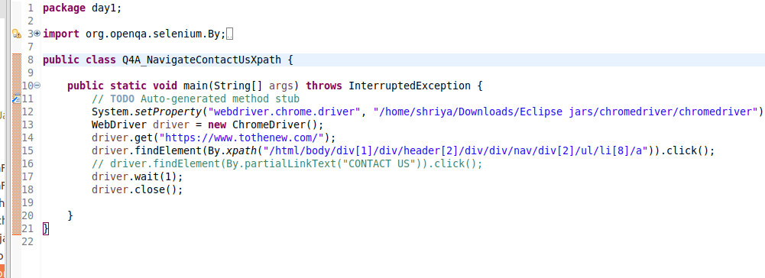

**2) ID**

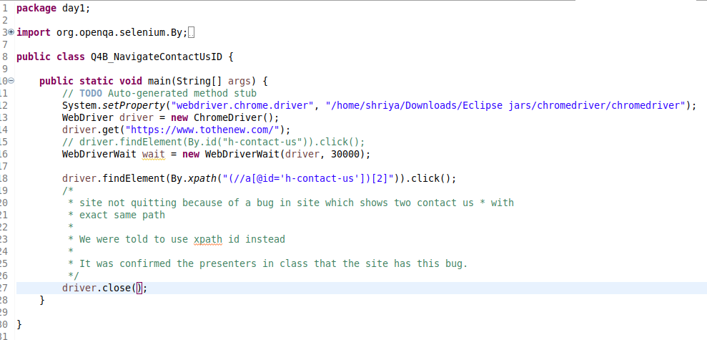

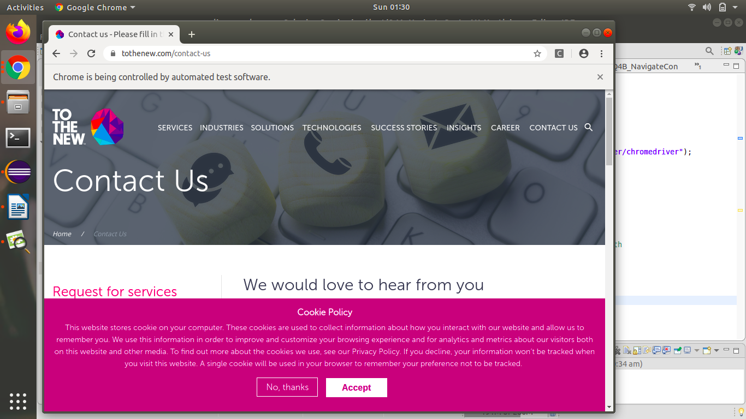

**Q5. Write a script to get the title of the “Contact Us” page.**

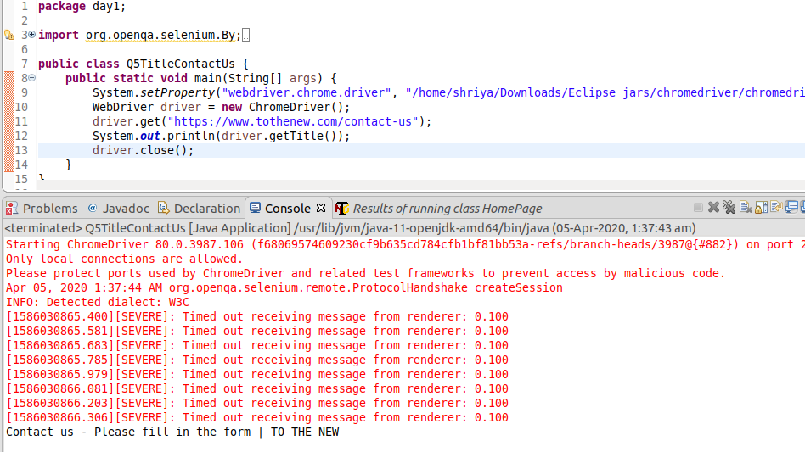

**Q6. Write a script to get the url of the "Contact Us' page.**

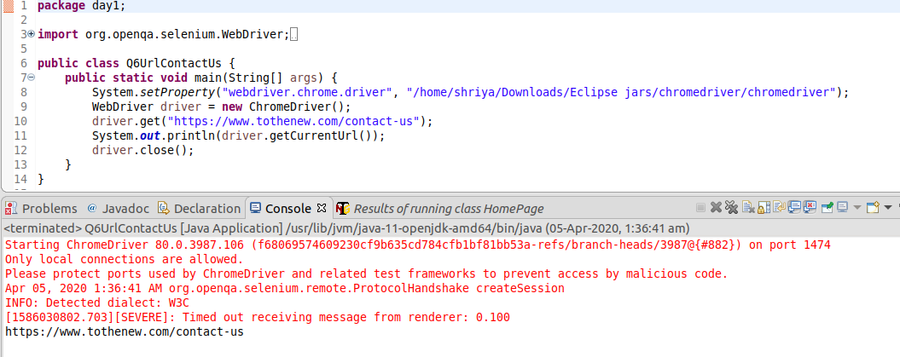

**Q7: Write the disadvantages of selenium.**

Disadvantages of Selenium are :

1. It supports Web-based applications only.
2. Difficult to use takes more time to create Test cases.
3. No reliable Technical Support from anybody.
4. Difficult to Setup Test Environment when it compares to Vendor Tools like UFT, RFT, SilkTest.
5. Limited support for Image Testing.
6. New features may not work properly.
7. No Test Tool integration for Test Management.
8. No Built-in Reporting facility.

**Q8: Difference between get() & navigate() method**

**driver.get() :** It's used to go to the particular website , But it doesn't maintain the browser History and cookies so , we can't use forward and backward button , if we click on that , page will not get schedule

**driver.navigate() :** it's used to go to the particular website , but it maintains the browser history and cookies, so we can use forward and backward button to navigate between the pages during the coding of Testcase

**Q9. What is the difference between Selenium RC & Selenium WebDriver.**

|  |  |
| --- | --- |
| **Selenium RC** | **Selenium WebDriver** |
| Required to start server before executing the test script. | Doesn’t required to start server before executing the test script. |
| It is standalone java program which allow you to run Html test suites. | It actual core API which has binding in a range of languages. |
| Core engine is Javascript based | Interacts natively with browser application |
| It is easy and small API | As compared to RC, it is bit complex and large API. |
| API’s are less Object oriented | API’s are entirely Object oriented |
| It doesn’t supports of moving mouse cursors. | It supports of moving mouse cursors. |
| Need to append full xpath with ‘xpath=\\’ syntax | No need to append full xpath with ‘xpath=\\’ syntax |
| It does not supports listeners | It supports the implementation of listeners |
| It does not support to test iphone/Android applications | It support to test iphone/Android applications |

**Q10. What are locators & types of locators in selenium**

Locator is a command that tells Selenium IDE which GUI elements ( say Text Box, Buttons, Check Boxes etc) its needs to operate on. Identification of correct GUI elements is a prerequisite to creating an automation script.

### The different locators in Selenium are as follows:

* By CSS ID: *find_element_by_id*
* By CSS class name: *find_element_by_class_name*
* By name attribute: *find_element_by_name*
* By DOM structure or xpath: *find_element_by_xpath*
* By link text: *find_element_by_link_text*
* By partial link text: *find_element_by_partial_link_text*
* By HTML tag name: *find_element_by_tag_name*

**Q11. Write an automation script for filling all fields of the registration page. (Registration.html)** *http://demo.automationtesting.in/Register.html*

a- Validate that Refresh button is disabled.

b- Validate that your respective gender is selected or not.

c- Validate that header of the registration page is Automation Demo Site.

d- Validate that title of the page is Register.

package day1;

import org.openqa.selenium.By;

import org.openqa.selenium.WebDriver;

import org.openqa.selenium.WebElement;

import org.openqa.selenium.chrome.ChromeDriver;

import org.openqa.selenium.support.ui.Select;

public class Q11RegistrationFormValidation {

public static void main(String[] args) throws InterruptedException {

// TODO Auto-generated method stub

System.setProperty("webdriver.chrome.driver", "/home/shriya/Downloads/Eclipse jars/chromedriver//chromedriver");

WebDriver driver =new ChromeDriver();

driver.get("http://demo.automationtesting.in/Register.html");

driver.findElement(By.xpath("//input[@placeholder='First Name']")).sendKeys("Shriya");

driver.findElement(By.xpath("//input[@placeholder='Last Name']")).sendKeys("Garg");

driver.findElement(By.xpath("//textarea[@class=\"form-control ng-pristine ng-untouched ng-valid\"]")).sendKeys("Greater Noida");

driver.findElement(By.xpath("//input[@type='email']")).sendKeys("shriya@gmail.com");

driver.findElement(By.xpath("//input[@type=\"tel\"]")).sendKeys("8373908033");

driver.findElement(By.xpath("//input[@value=\"FeMale\"]")).click();

driver.findElement(By.id("checkbox2")).click();

driver.findElement(By.id("msdd")).click();

driver.findElement(By.linkText("Korean")).click();

driver.findElement(By.linkText("Italian")).click();

driver.findElement(By.id("basicBootstrapForm")).click();

Select skills=new Select(driver.findElement(By.id("Skills")));

skills.selectByValue("C++");

Select country=new Select(driver.findElement(By.id("countries")));

country.selectByValue("India");

driver.findElement(By.xpath("//b[@role]")).click();

driver.findElement(By.xpath("/html/body/span/span/span[1]/input")).sendKeys("Denmark");

driver.findElement(By.xpath("/html/body/span/span/span[2]/ul/li")).click();

driver.findElement(By.xpath("//select[@placeholder='Year']")).sendKeys("2014");

driver.findElement(By.xpath("//select[@placeholder='Month']")).sendKeys("October");

driver.findElement(By.xpath("//select[@placeholder='Day']")).sendKeys("7");

driver.findElement(By.id("firstpassword")).sendKeys("Shriya123");

driver.findElement(By.id("secondpassword")).sendKeys("Shriya123");

//Validate that Refresh button is disabled.

WebElement refreshButton = driver.findElement(By.id("Button1"));

if(refreshButton.isEnabled())

System.out.println("Refresh button is enabled");

else

System.out.println("Refresh button is disabled");

//Validate that your respective gender is selected or not.

if (driver.findElement(By.xpath("//input[@value=\"FeMale\"]")).isSelected())

System.out.println("Correct gender selected");

else

System.out.println("Incorrect gender is selected");

// Validate that header of the registration page is Automation Demo Site.

String title = driver.findElement(By.xpath("//*[@id=\"header\"]/div/div/div/div[2]/h1")).getText();

if(title.equals("Automation Demo Site"))

System.out.println("Heading of page is: " +title+ "; Hence validated");

else

System.out.println("Invalid heading");

// Validate that title of the page is Register.

String pageTitle = driver.getTitle();

if(pageTitle.equals("Register"))

System.out.println("Title of page is: " +pageTitle+ "; Hence validated");

else

System.out.println("Invalid title of page");

}

}

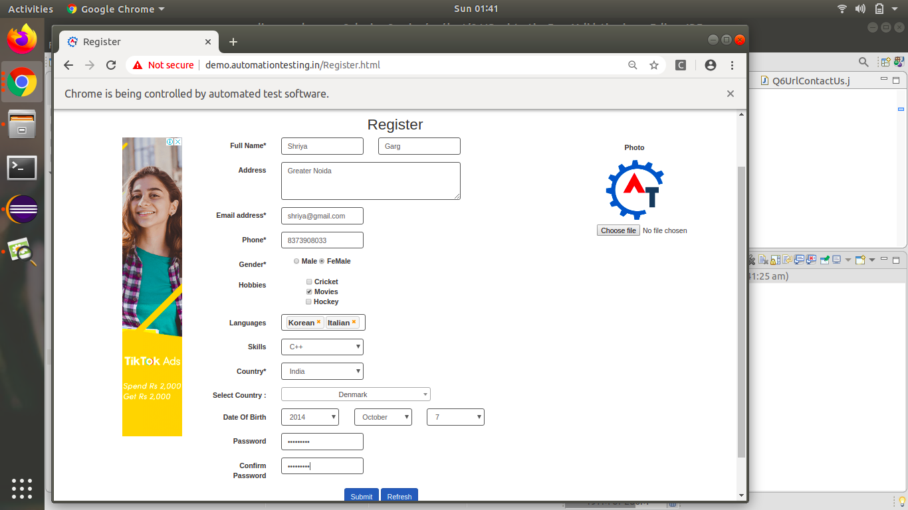

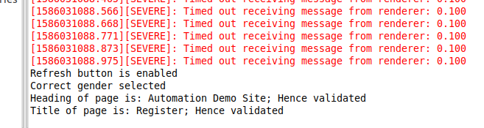

**Q12. Write an automation script for filling FirstName, LastName & Email address field with the help of name locator. (Registration.html)**

